**A PROJECT REPORT**

**on**

**“Mental Disorders Detection via**

**Social Media Mining”**

**Submitted to**

**KIIT Deemed to be University**

**In Partial Fulfilment of the Requirement for the Award of**

**BACHELOR’S DEGREE IN**

**INFORMATION TECHNOLOGY**

**BY**

**Aniket Kumar Mishra**

**Ujjwal Singh**

**Abdul Wahid Aadil**

**Ankit Dev**

**Siddarth**

2029187

2029193

2029194

2029195

2029214

**UNDER THE GUIDANCE OF**

1. **Neha**



**SCHOOL OF COMPUTER ENGINEERING**

**KALINGA INSTITUTE OF INDUSTRIAL TECHNOLOGY**

**BHUBANESWAR, ODISHA - 751024**

**May 2020**

A PROJECT REPORT

on

“Mental Disorders Detection via Online Social Media Mining”

Submitted to

KIIT Deemed to be University

In Partial Fulfilment of the Requirement for the Award of

BACHELOR’S DEGREE IN INFORMATION TECHNOLOGY

**BY**

**Aniket Kumar Mishra**

**Ujjwal Singh**

**Abdul Wahid Aadil**

**Ankit Dev**

**Siddarth**

2029187

2029193

2029194

2029195

2029214

**UNDER THE GUIDANCE OF**

**B. Neha**



SCHOOL OF COMPUTER ENGINEERING

KALINGA INSTITUTE OF INDUSTRIAL TECHNOLOGY

BHUBANESWAE, ODISHA -751024

May 2022

KIIT Deemed to be University

School of Computer Engineering

Bhubaneswar, ODISHA 751024



CERTIFICATE

This is certify that the project entitled

“Mental Disorders Detection via Online Social Media Mining”

submitted by

**Aniket Kumar Mishra**

**Ujjwal Singh**

**Abdul Wahid Aadil**

**Ankit Dev**

**Siddarth**

2029187

2029193

2029194

2029195

2029214

is a record of bonafide work carried out by them, in the partial fulfilment of the requirement for the award of Degree of Bachelor of Engineering (Computer Sci-ence & Engineering OR Information Technology) at KIIT Deemed to be university, Bhubaneswar. This work is done during year 2022-2023, under our guidance.

Date: 01 / 05 / 2024

B.Neha

(Guide Name)

**Acknowledgements**

We are profoundly grateful to **B. Neha** of **Affiliation** for her expert guidance and continuous encouragement throughout to see that this project rights its target since its commencement to its completion. .....................

**Aniket Kumar Mishra** (2029187)

**Ujjwal Singh** (2029193)

**Abdul Wahid Aadil** (2029194)

**Ankit Dev** (2029195)

**Siddarth** (2029214)

**ABSTRACT**

The widespread adoption of social networking has led to problematic usage and a rise in social network mental disorders (SNMDs) like Cyber-Relationship Addiction, Information Overload, and Net Compulsion. Currently, symptoms of these disorders are often observed passively, resulting in delayed clinical intervention. In this paper, we argue that mining online social behavior offers an opportunity to actively identify SNMDs early on. Detecting SNMDs is challenging as mental status cannot be directly observed from online activity logs. Our novel approach does not rely on self-disclosure via Psychology questionnaires but instead proposes a machine learning framework called Social Network Mental Disorder Detection (SNMDD). SNMDD utilizes features extracted from social network data to accurately identify potential SNMD cases. We further enhance SNMDD's accuracy by incorporating multi-source learning and introducing a new SNMD-based Tensor Model (STM), focusing on scalability and efficiency. To evaluate our framework, we conduct a user study involving 3126 online social network users. Through feature analysis and application of SNMDD on large-scale datasets, we analyze the characteristics of the three SNMD types. Our results demonstrate the promise of SNMDD in identifying potential SNMD cases among online social network users.

**Keywords:** Social networking, social network mental disorders (SNMDs), Cyber-Relationship Addiction, Information Overload, Net Compulsion, online social behavior, SNMD detection, machine learning framework

窗体顶端

窗体底端

Contents

|  |  |  |  |  |
| --- | --- | --- | --- | --- |
| 1 | Introduction | | |  |
| 2 | Basic Concepts/ Literature Review | | |  |
|  | 2.1 | Tools and Techniques | |  |
|  | 2.2 | Literature Review | |  |
| 3 | Problem Statement / Requirement Specifications | | |  |
|  | 3.1 | Project Planning........................... | |  |
|  | 3.2 | Project Analysis (SRS)................. | |  |
|  | 3.3 | System Design ………………….. | |  |
|  |  | 3.3.1 | Design Constraints …… |  |
|  |  | 3.3.2 | System Architecture (UML) / Block Diagram … |  |
| 4 | Implementation | | |  |
|  | 4.1 | Methodology / Proposal ........................... | |  |
|  | 4.2 | Testing / Verification Plan ……………. | |  |
|  | 4.3 | Result Analysis / Screenshots …………. | |  |
|  | 4.4 | Quality Assurance …………………….. | |  |
| 5 | Standard Adopted | | |  |
|  | 5.1 | Design Standards . . . . . . . . . . . . . . . | |  |
|  | 5.2 | Coding Standards . . . . . . . . . . . . . . | |  |
|  | 5.3 | Testing Standards . . . . . . . . . . . . . . . | |  |
| 6 | Conclusion and Future Scope | | |  |
|  | 6.1 | Conclusion ……………………….. | |  |
|  | 6.2 | Future Scope ………………………. | |  |
| References | | | |  |
| Individual Contribution | | | |  |
|  | | | |  |

Chapter 1

Introduction

Data mining, also known as knowledge discovery, involves analyzing data from various angles to extract valuable insights. These insights can be used to enhance revenue, reduce costs, or both. Data mining software enables users to analyze data from multiple dimensions, categorize it, and identify relationships. It works by finding correlations or patterns among numerous fields in large databases.

Data mining software utilizes different analytical techniques, including statistical analysis, machine learning, and neural networks. It seeks four types of relationships: classes, clusters, associations, and sequential patterns. Classes involve locating data in predetermined groups, while clusters group data items based on logical relationships or consumer preferences. Associations identify connections within data, while sequential patterns anticipate behavior trends.

The data mining process comprises five major elements: extracting, transforming, and loading transaction data onto a data warehouse system; storing and managing data in a multidimensional database system; providing data access to analysts and IT professionals; analyzing data using application software; and presenting data in a useful format.

Various levels of analysis are available in data mining, including artificial neural networks, genetic algorithms, decision trees, nearest neighbor methods, rule induction, and data visualization. These techniques enable organizations to extract valuable insights from complex datasets.

Data mining is characterized by large quantities of data, noisy and incomplete data, complex data structures, and heterogeneous data stored in legacy systems. Despite these challenges, data mining offers numerous benefits across industries.

*School of Computer Engineering, KIIT, BBSR* 1

Chapter 2

Basic Concepts/ Literature Review

Data mining bridges the gap between transactional and analytical systems within large-scale information technology. It involves analyzing stored transaction data through data mining software, which responds to open-ended user queries to uncover relationships and patterns.

**2.1 Basic concepts about the related tools and techniques :**

1. Web Acquiring, transforming, and transferring transaction data to the data warehouse system.
2. Organizing and overseeing data within a multidimensional database framework.

3.Granting data access to business analysts and IT experts.

1. Employing application software to analyze the data.
2. Displaying the findings in a practical format, such as graphs or tables

**2.2 Literature Review :**

1) **Cyber-disorders:** The mental health concern for the new millennium.

By K. Young, M. Pistner, J. O’Mara, and J. Buchanan.

This study explores the rise in clients reporting Internet-related issues to mental health practitioners. It surveyed therapists treating clients with cyber-related problems, finding an average caseload of nine Internet-addicted clients. Treatment strategies included cognitive-behavioral approaches and social skills training. The study discusses the impact of cyber-disorders on future research, treatment, and public policy.

2) **Internet addiction**: the emergence of a new clinical disorder

By K. Young

This study investigates Internet addiction's existence and its effects, drawing parallels with Pathological Gambling. It introduces a Diagnostic Questionnaire (DQ) and classifies participants as dependent or nondependent Internet users. Qualitative analysis reveals significant differences between the two groups in usage behavior and functional impairment.

3) The association between suicidality and Internet addiction and activities in Taiwanese adolescents

By I.-H. Lin, C.-H. Ko, Y.-P. Chang, T.-L. Liu, P.-W. Wang, H.-C. Lin, M.-F. Huang, Y.-C. Yeh, W.-J. Chou, and C.-F

This cross-sectional study examines the link between suicidal ideation/attempts and Internet addiction/activities in Taiwanese adolescents. Internet addiction is significantly associated with suicidal ideation/attempts, with different online activities showing varying degrees of risk.

4) Social and parasocial relationships on social network sites and their differential relationships with users’ psychological well-being.

By Y. Baek, Y. Bae, and H. Jang

This study explores the impact of social and parasocial relationships on psychological well-being among social network site (SNS) users. It identifies two types of relationships and their associations with social isolation, interpersonal trust, and SNS addiction, finding dependency on both types correlated with SNS addiction.

*School of Computer Engineering, KIIT, BBSR* 3

Chapter 3

Problem Statement / Requirement Specifications

3.2 Project Analysis

**Existing System:**

Kim et al. explore the link between sleep quality and suicide attempts among Internet addicts, while recent studies in Psychology and Sociology identify various mental factors associated with social network mental disorders. Chang et al. use an NLP-based approach to extract linguistic and content-based features from online social media to detect Borderline Personality Disorder and Bipolar Disorder patients. Saha et al. analyze topical and linguistic features from social media data of depression patients to understand their patterns. Choudhury et al. examine emotion and linguistic styles in social media data to identify Major Depressive Disorder (MDD). However, previous research mainly focuses on individual behaviors and textual content, neglecting the examination of social network structures and potential psychological features.

**Disadvantages of Existing System:**

Previous psychological research has highlighted key mental factors associated with SNMDs, often assessed through standard diagnostic surveys. However, automatically detecting potential SNMD cases among online social network (OSN) users and extracting these factors to evaluate their online mental states presents significant challenges. Observing factors like loneliness extent and the impact of disinhibition on OSN users is not straightforward. Existing schemes are ill-equipped to handle sparse data from multiple OSNs, and SNMD data across different platforms may be incomplete due to heterogeneity.

**Proposed System:**

In this paper, we propose leveraging social network data alongside traditional psychological methods to actively identify SNMD cases early on. We introduce a machine learning framework, SNMDD, designed specifically for SNMD detection. To address the challenge of multi-source learning, we present the SNMD-based Tensor Model (STM). Our innovative approach involves mining data logs of OSN users to establish an early detection system. Additionally, we develop and analyze various features crucial for SNMD identification from OSNs, including disinhibition, parasociality, and self-disclosure. This framework offers the potential for early alerts regarding potential SNMD patients.

**Advantages of Proposed System:**

Our approach offers several advantages:

* The novel STM incorporates SNMD characteristics into the tensor model using Tucker decomposition.
* The tensor factorization captures the structure, latent factors, and feature correlations, providing a comprehensive user behavior profile.
* We introduce STM-CP-SGD, a stochastic gradient descent algorithm based on CANDECOMP/PARAFAC (CP) decomposition, addressing efficiency and solution uniqueness concerns in traditional Tucker decomposition.
* The convergence rate is significantly enhanced with STM-CP-2SGD, a second-order stochastic gradient descent algorithm.
* We reduce computation time by designing an approximation scheme for the second-order derivative, the Hessian matrix, supported by theoretical analysis.

**3.3 System Design**

**SYSTEM DESIGN**

**SYSTEM ARCHITECTURE:**

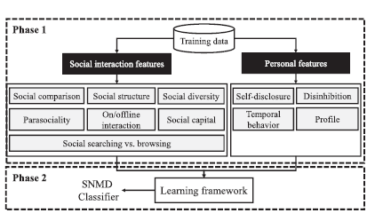

**3.3.1 Design Constraints**

**INPUT DESIGN AND OUTPUT DESIGN**

**INPUT DESIGN**

The input design is the link between the information system and the user. It comprises the developing specification and procedures for data preparation and those steps are necessary to put transaction data in to a usable form for processing can be achieved by inspecting the computer to read data from a written or printed document or it can occur by having people keying the data directly into the system. The design of input focuses on controlling the amount of input required, controlling the errors, avoiding delay, avoiding extra steps and keeping the process simple. The input is designed in such a way so that it provides security and ease of use with retaining the privacy. Input Design considered the following things:

* What data should be given as input?
* How the data should be arranged or coded?
* The dialog to guide the operating personnel in providing input.
* Methods for preparing input validations and steps to follow when error occur.

**OBJECTIVES**

1. Input Design is the process of converting a user-oriented description of the input into a computer-based system. This design is important to avoid errors in the data input process and show the correct direction to the management for getting correct information from the computerized system.

2. It is achieved by creating user-friendly screens for the data entry to handle large volume of data. The goal of designing input is to make data entry easier and to be free from errors. The data entry screen is designed in such a way that all the data manipulates can be performed. It also provides record viewing facilities.

3. When the data is entered it will check for its validity. Data can be entered with the help of screens. Appropriate messages are provided as when needed so that the user will not be in maize of instant. Thus the objective of input design is to create an input layout that is easy to follow

**OUTPUT DESIGN**

A quality output is one, which meets the requirements of the end user and presents the information clearly. In any system results of processing are communicated to the users and to other system through outputs. In output design it is determined how the information is to be displaced for immediate need and also the hard copy output. It is the most important and direct source information to the user. Efficient and intelligent output design improves the system’s relationship to help user decision-making.

1. Designing computer output should proceed in an organized, well thought out manner; the right output must be developed while ensuring that each output element is designed so that people will find the system can use easily and effectively. When analysis design computer output, they should Identify the specific output that is needed to meet the requirements.

2. Select methods for presenting information.

3. Create document, report, or other formats that contain information produced by the system.

The output form of an information system should accomplish one or more of the following objectives.

* Convey information about past activities, current status or projections of the
* Future.
* Signal important events, opportunities, problems, or warnings.
* Trigger an action.
* Confirm an action.

**BLOCK DIAGRAM:**

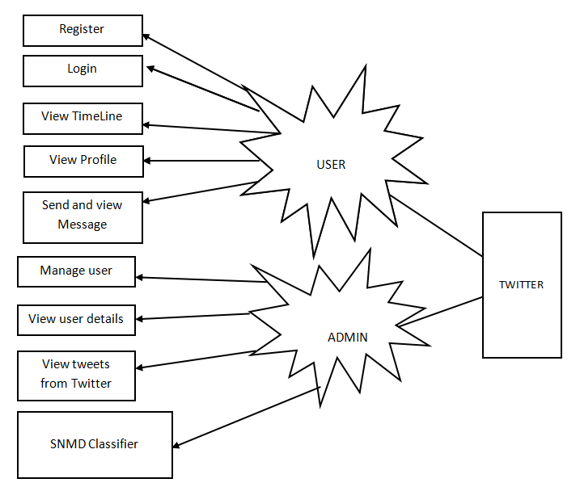

**DATA FLOW DIAGRAM:**

* A Data Flow Diagram (DFD), also known as a bubble chart, simplifies system representation by illustrating the flow of data within a system.
* It consists of input data, processing operations, and output data, represented through graphical elements.
* DFDs are essential modeling tools used to depict system components, including processes, data, external entities, and information flows.
* They show how information moves through the system and undergoes transformations during processing.
* DFDs can represent systems at various levels of abstraction and can be partitioned into levels to depict increasing information flow and functional detail.
* Also referred to as bubble charts, DFDs provide a clear visualization of data flow and processing within a system.

CSP

Client Login Authorized

Manage user details

Check the user tweets

SNMD Classifier

User Tweet Observation

Logout

View TimeLine post from the Twitter

View Profile details

Logout

Login

Register

USER

ADMIN

Compose tweet

Sent message

view message

**UML DIAGRAMS**

* UML stands for Unified Modeling Language and is a standardized modeling language used in object-oriented software engineering.
* Managed by the Object Management Group, UML aims to be a common language for creating models of software systems.
* UML consists of two major components: a Meta-model and a notation, with potential additions of methods or processes in the future.
* It serves as a standard language for specifying, visualizing, constructing, and documenting software artifacts and business models.
* UML embodies best engineering practices for modeling large and complex systems.
* It plays a crucial role in developing object-oriented software and the software development process, primarily utilizing graphical notations for design expression.

**GOALS:**

* Provide users with a ready-to-use, expressive visual modeling language for developing and exchanging meaningful models.
* Incorporate extendibility and specialization mechanisms to enhance the core concepts.
* Ensure independence from specific programming languages and development processes.
* Establish a formal basis for understanding the modeling language.
* Foster the growth of the object-oriented (OO) tools market.
* Support higher-level development concepts like collaborations, frameworks, patterns, and components.
* Integrate best practices into the UML design.

**USE CASE DIAGRAM:**

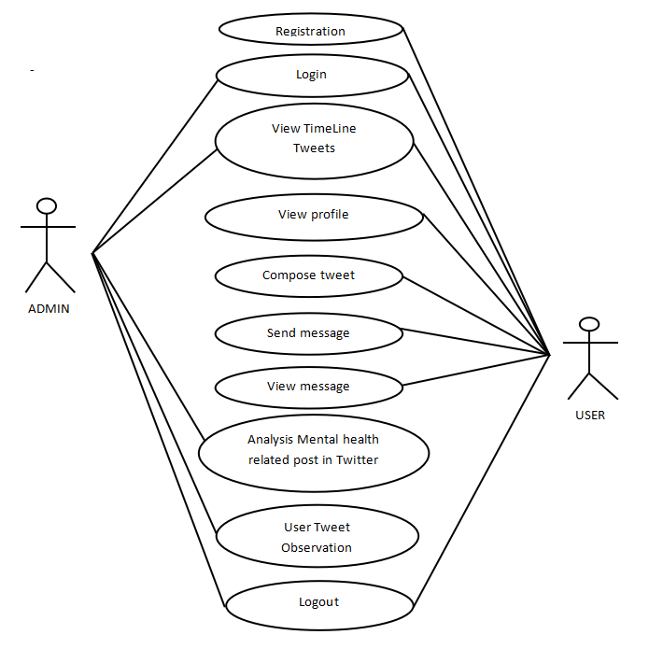

**CLASS DIAGRAM**

USER

Login

View TimeLine Tweets ()

compose tweet ()

follow friends ()

send message ()

view message ()

ADMIN

Login

View User Details ()   
View TimeLine Tweets()  
Analysis Mental health related post in Twitter ()  
User Tweet Observation ()

TWITTER

TRWITTER

**SEQUENCE DIAGRAM:**

Compose tweets

View TimeLine post from Twitter

TWITTER

USER

ADMIN

Analysis Mental health related post from the Twitter

Check the Overall user stress level

Send and view message

View User Details

**SYSTEM REQUIREMENTS:**

**HARDWARE REQUIREMENTS:**

* System : Pentium IV 2.4 GHz.
* Hard Disk : 40 GB.
* Floppy Drive : 1.44 Mb.
* Monitor : 15 VGA Colour.
* Mouse : Logitech.
* Ram : 512 Mb.

**SOFTWARE REQUIREMENTS:**

* Operating system : - Windows XP/7.
* Coding Language : JAVA/J2EE
* Data Base : MYSQL

Chapter 4

Implementation

In this section, present the implementation done by us during the project development.

**MODULES:**

* Data Collection
* Training
* Classification

**MODULES DESCRIPTION:**

**Data Collection;**

We first extract a number of social interaction features to capture the user behavior on social media.

**Parasocial relationship (PR).** The feature of parasocial relationship is represented as |aout|/|ain|, where |aout| and |ain| denote the number of actions a user takes to friends and the number of actions friends take to the user, respectively

**Online and offline interaction ratio (ONOFF).**As observed by mental health professionals, people who indulge themselves in OSNs tend to snub their friends in real life We extract the number of check-in logs with friends and the number of “going” events as an indicator of the number of offline activities to estimate the online (|aon|)/offline (|aoff |) interaction ratio.

**Social capital (SC).**Two types of friendship ties are usually involved in the theory of social capital i) Bond strengthening (strong-tie), which represents the use of OSNs to strengthen the relationships; and ii) Information seeking (weak-tie), which corresponds to the use of social media to find valuable information.

**Social searching vs. browsing (SSB).**The human appetitive system is in charge of the addictive behavior. It shows social searching (actively reading news feeds from friends’ walls) creates more pleasure than social browsing (passively reading personal news feeds).

**Personal features**: The duration, **Self-disclosure based features,Temporal behavior features are**  extracted from thepersonal profiles of OSN users

**Training:**

The given SNMD features of N users extracted from M OSN sources, we construct a three-mode tensor T ∈ RN×D×M and then conduct Tucker decomposition, a renowned tensor decomposition technique, on T to extract a latent feature matrix **U**, which presents the latent features of each person summarized from all OSNs. We aim to feed these latent features for SNMD detection. Matrix **U** effectively estimates a deficit feature (e.g., a missing feature value unavailable due to privacy setting) of an OSN from the corresponding feature of other OSNs, together with the features of other users with similar behavior. Based on Tucker decomposition on T , we present a new SNMD-based Tensor Model (STM), which enables **U** to incorporate important characteristics of SNMDs, such as the correlation of the same SNMD sharing among close friends.

**Classification:**

Finally, equipped with the new tensor model, we conduct semi-supervised learning to classify each user by exploiting mini batch gradient descent algorithm. Mini-batch gradient descent is a variation of the gradient descent algorithm that splits the training dataset into small batches that are used to calculate model error and update model coefficients. Mini-batch gradient descent seeks to find a balance between the robustness of stochastic gradient descent and the efficiency of batch gradient descent. Finally predict what type of disorder.

**4.2 Testing OR Verification Plan**

**SYSTEM TESTING**

Testing serves the purpose of identifying errors and weaknesses in a work product, encompassing components, assemblies, or finished products. It is a process of verifying the functionality of software to ensure it meets requirements and user expectations, aiming to prevent unacceptable failures. There are various types of tests, each addressing specific testing requirements.

**TYPES OF TESTS**

**Unit testing**

Unit testing validates the internal logic of a program by designing test cases to ensure proper functionality and valid outputs for program inputs. It focuses on testing individual software units after their completion and before integration, examining decision branches and internal code flow. This structural testing is invasive and relies on knowledge of the program's construction. Unit tests perform basic tests at the component level, ensuring accuracy and adherence to specifications for each unique path of a business process.

**Integration testing**

Integration tests are designed to test integrated software components to determine if they actually run as one program. Testing is event driven and is more concerned with the basic outcome of screens or fields. Integration tests demonstrate that although the components were individually satisfaction, as shown by successfully unit testing, the combination of components is correct and consistent. Integration testing is specifically aimed at exposing the problems that arise from the combination of components.

**Functional test**

**Purpose of Functional Testing:**

* Validate that functions meet specified requirements, system documentation, and user manuals.

**Key Aspects Covered:**

* Valid Input: Acceptance of identified classes of valid input.
* Invalid Input: Rejection of identified classes of invalid input.
* Functions: Exercise of identified functions.
* Output: Exercise of identified classes of application outputs.
* Systems/Procedures: Invocation of interfacing systems or procedures.
* Organization and Preparation:
* Emphasizes requirements, key functions, and special test cases.
* Ensures systematic coverage of business process flows, data fields, predefined processes, and successive processes.
* Completion Process:
* Identifies additional tests and evaluates the effectiveness of current tests before concluding functional testing.

**System Test**

System testing ensures that the entire integrated software system meets requirements. It tests a configuration to ensure known and predictable results. An example of system testing is the configuration oriented system integration test. System testing is based on process descriptions and flows, emphasizing pre-driven process links and integration points.

**White Box Testing**

White Box Testing is a testing in which in which the software tester has knowledge of the inner workings, structure and language of the software, or at least its purpose. It is purpose. It is used to test areas that cannot be reached from a black box level.

**Black Box Testing**

Black Box Testing is testing the software without any knowledge of the inner workings, structure or language of the module being tested. Black box tests, as most other kinds of tests, must be written from a definitive source document, such as specification or requirements document, such as specification or requirements document. It is a testing in which the software under test is treated, as a black box .you cannot “see” into it. The test provides inputs and responds to outputs without considering how the software works.

**Unit Testing:**

Unit testing is usually conducted as part of a combined code and unit test phase of the software lifecycle, although it is not uncommon for coding and unit testing to be conducted as two distinct phases.

**Test strategy and approach**

Field testing will be performed manually and functional tests will be written in detail.

**Test objectives**

* All field entries must work properly.
* Pages must be activated from the identified link.
* The entry screen, messages and responses must not be delayed.

**Features to be tested**

* Verify that the entries are of the correct format
* No duplicate entries should be allowed
* All links should take the user to the correct page.

# Integration Testing

Software integration testing is the incremental integration testing of two or more integrated software components on a single platform to produce failures caused by interface defects.

The task of the integration test is to check that components or software applications, e.g. components in a software system or – one step up – software applications at the company level – interact without error.

**Test Results:** All the test cases mentioned above passed successfully. No defects encountered.

**6.3 Acceptance Testing**

User Acceptance Testing is a critical phase of any project and requires significant participation by the end user. It also ensures that the system meets the functional requirements.

**Test Results:** All the test cases mentioned above passed successfully. No defects encountered.

**4.3 Screenshots**



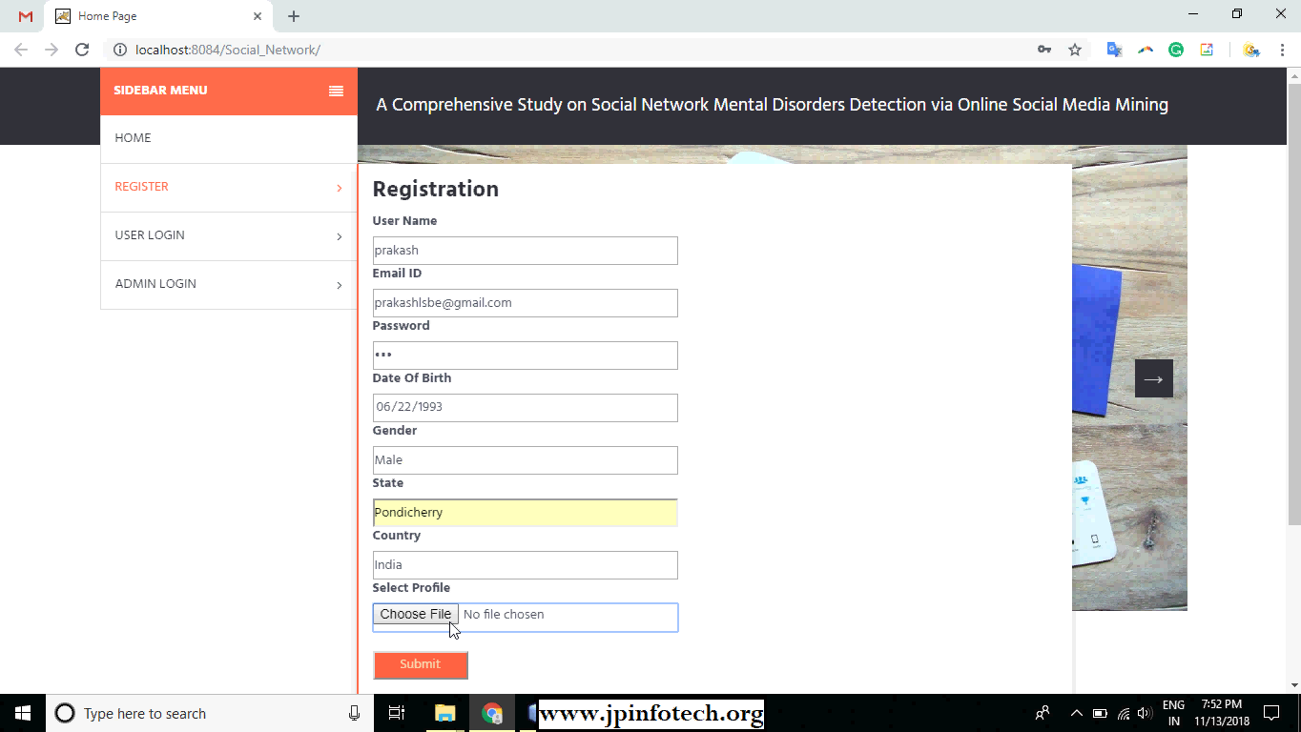

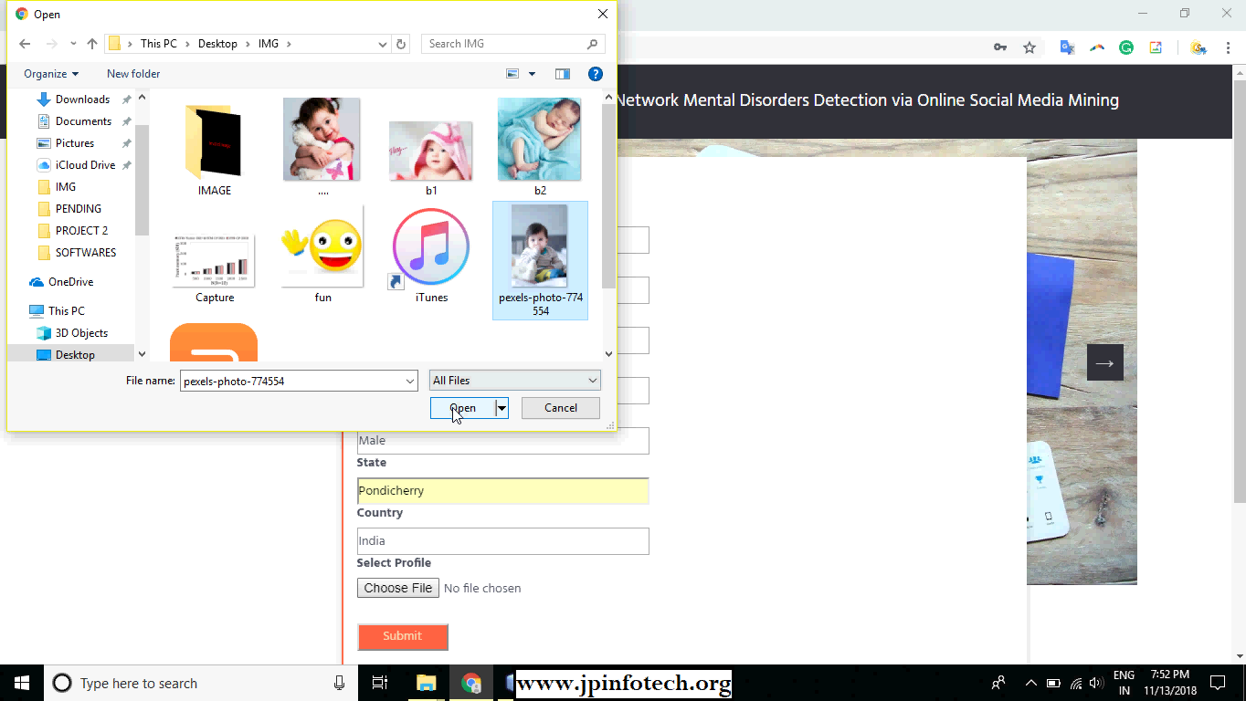



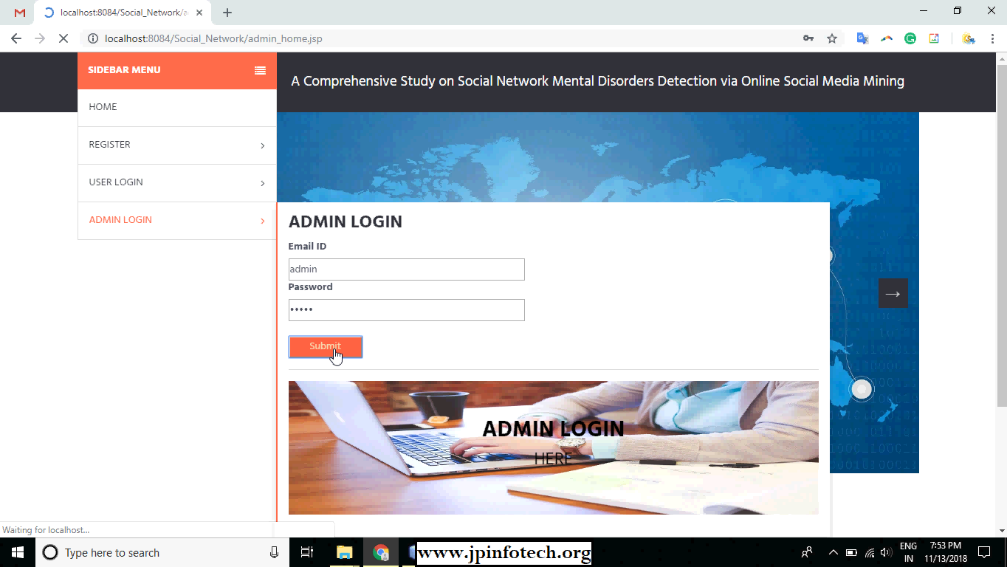



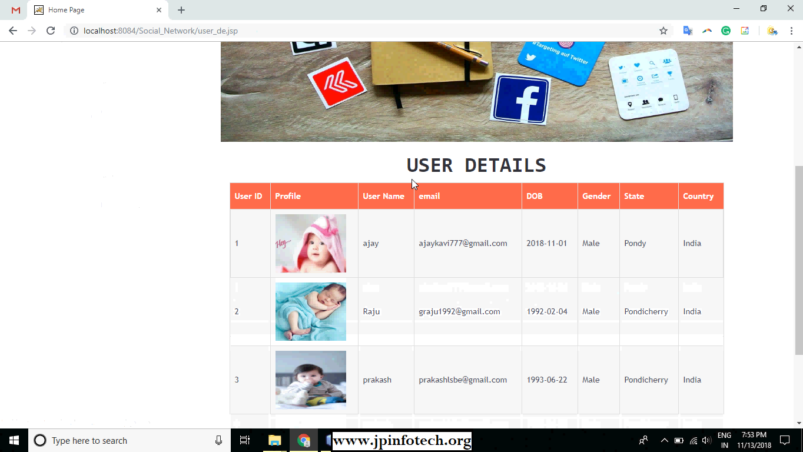

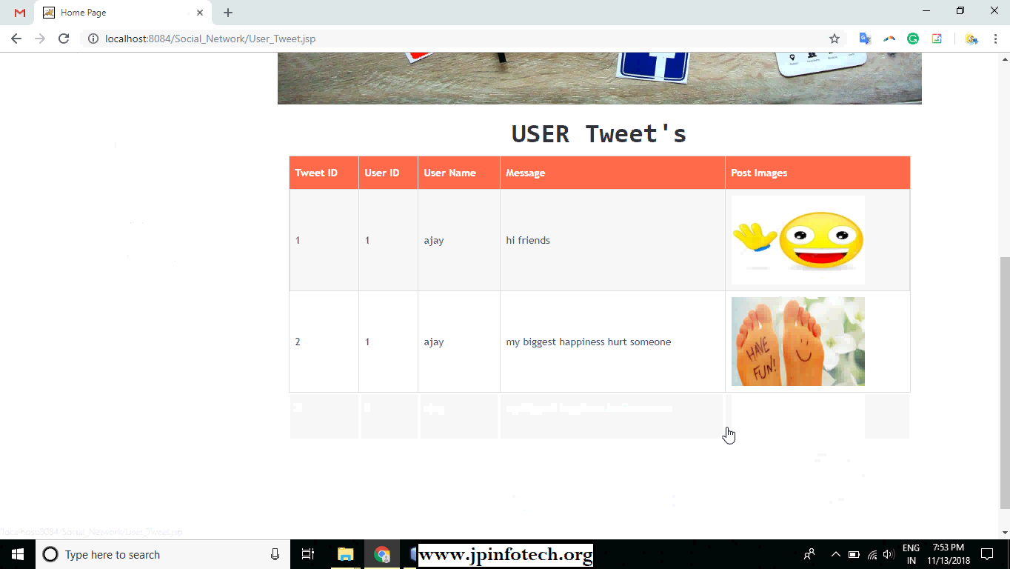

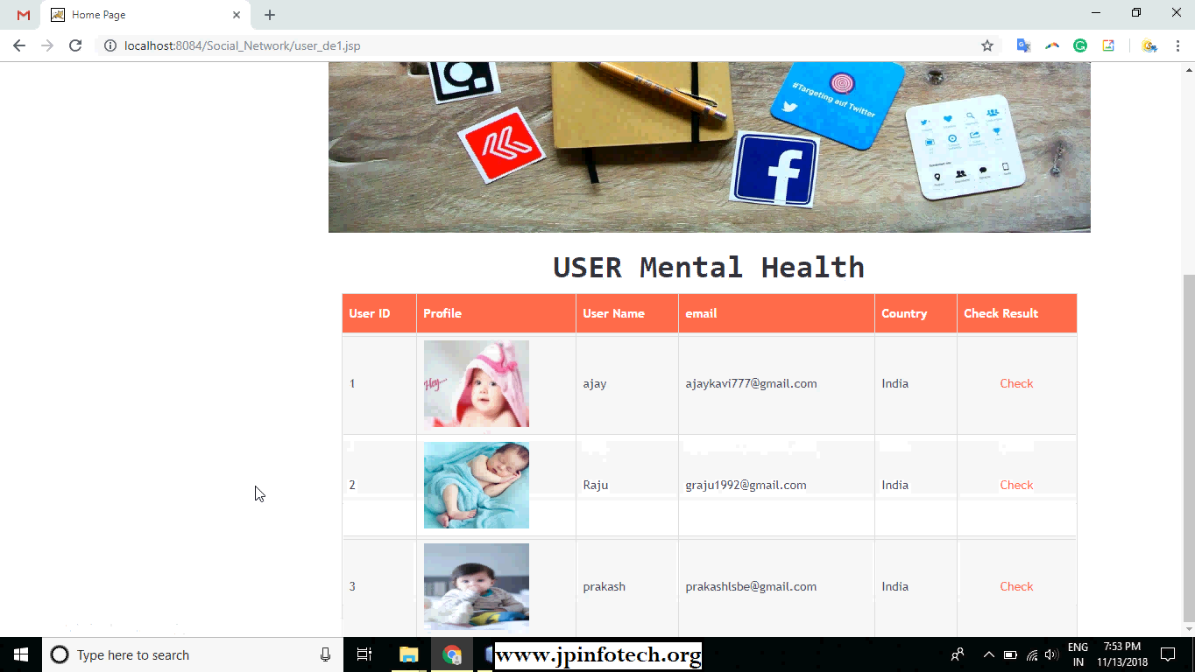

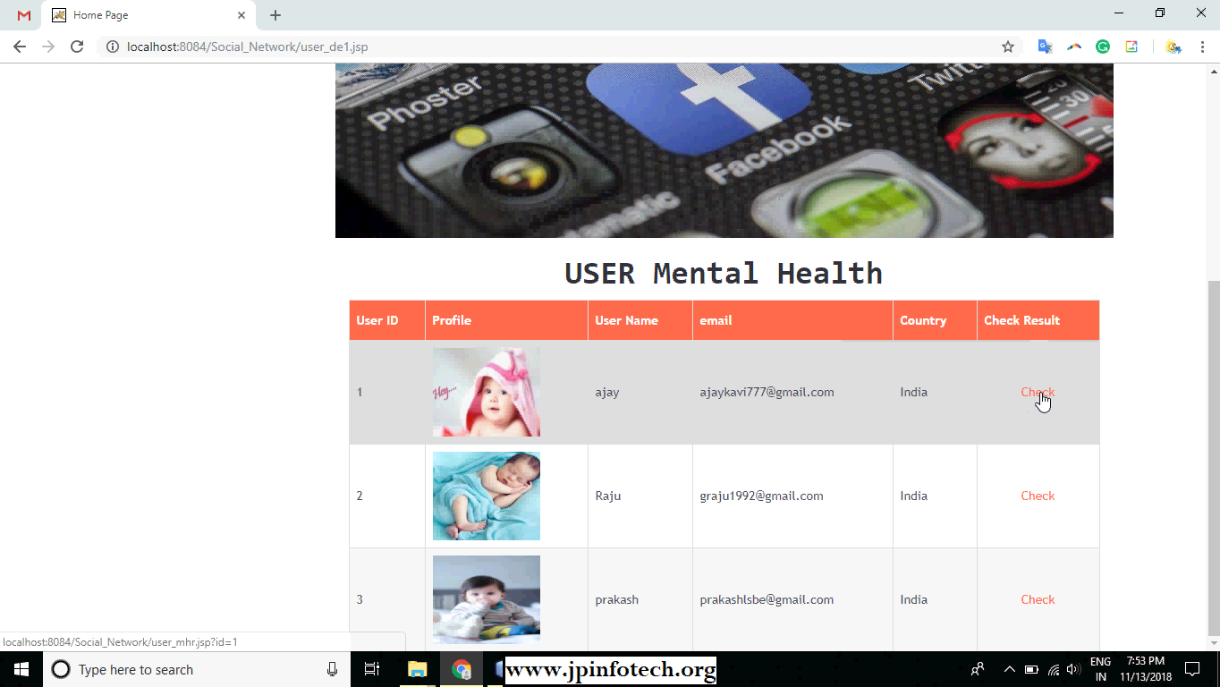

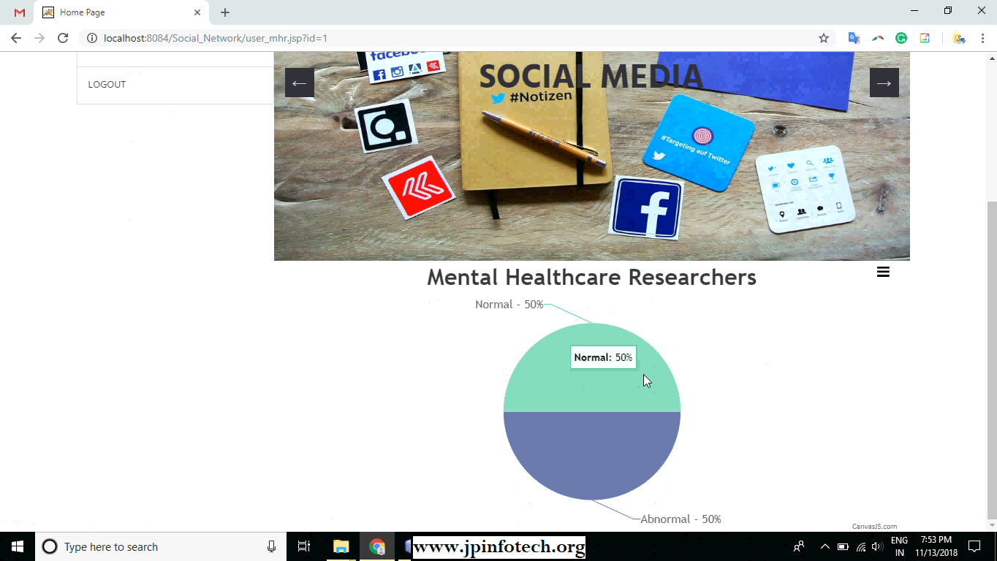

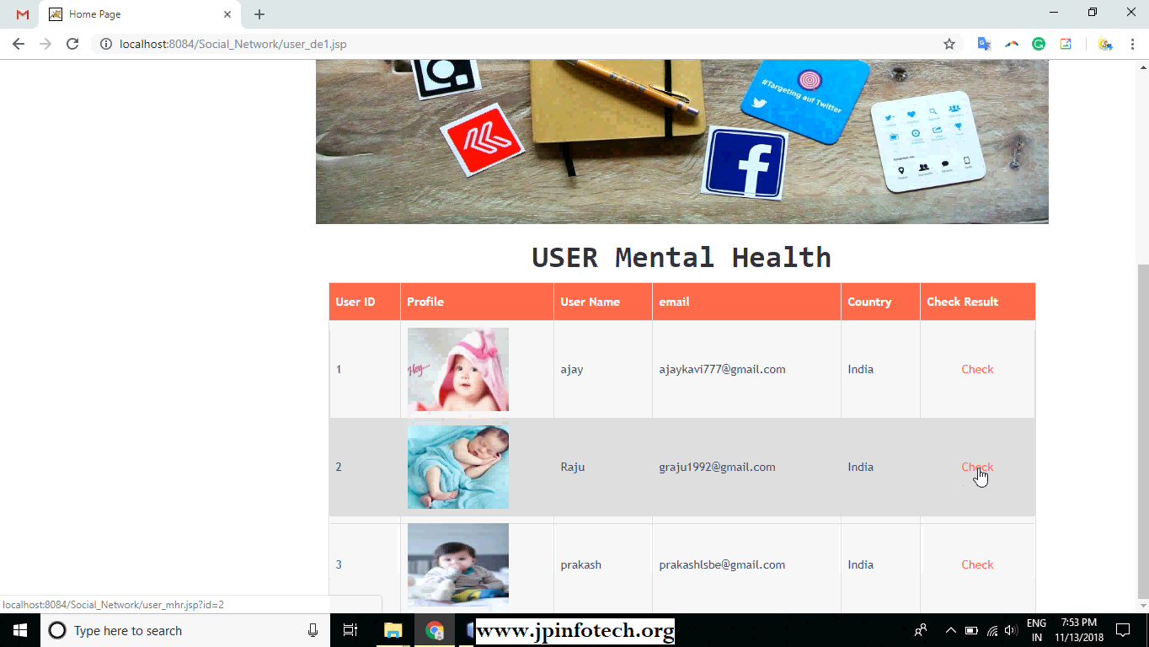

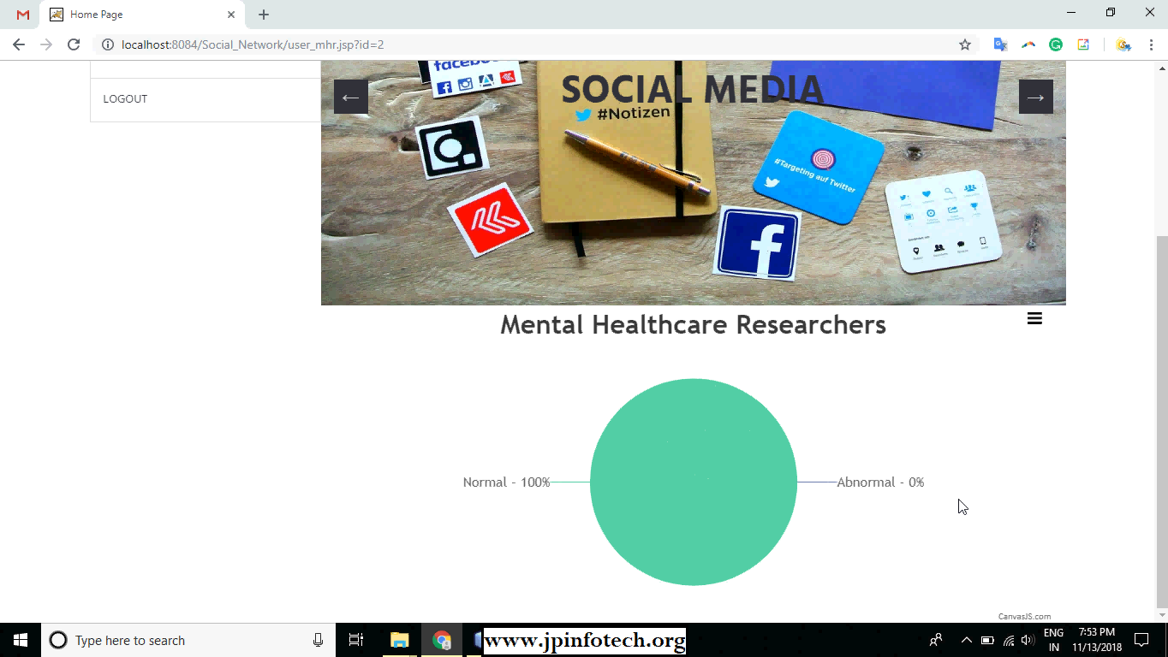

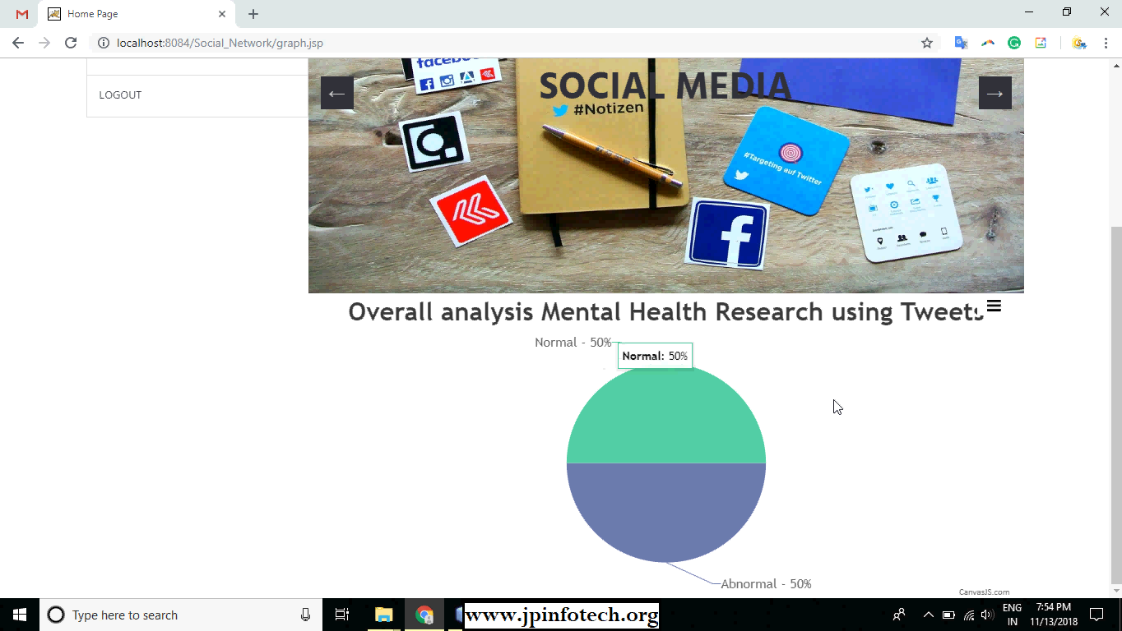

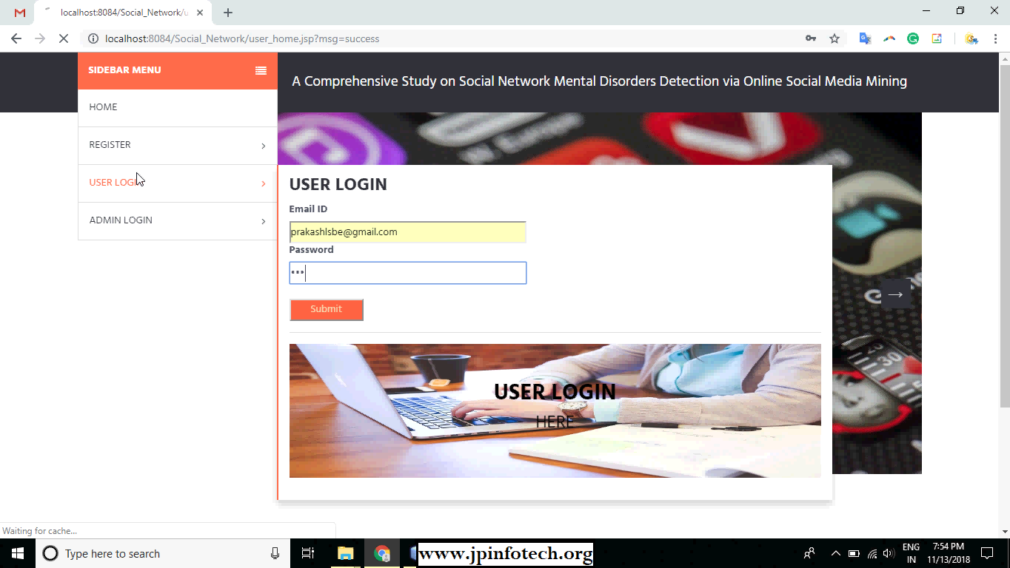



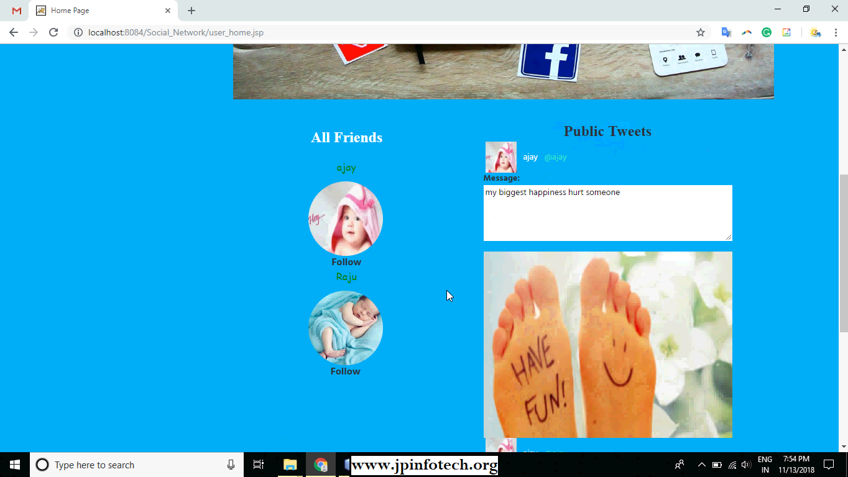



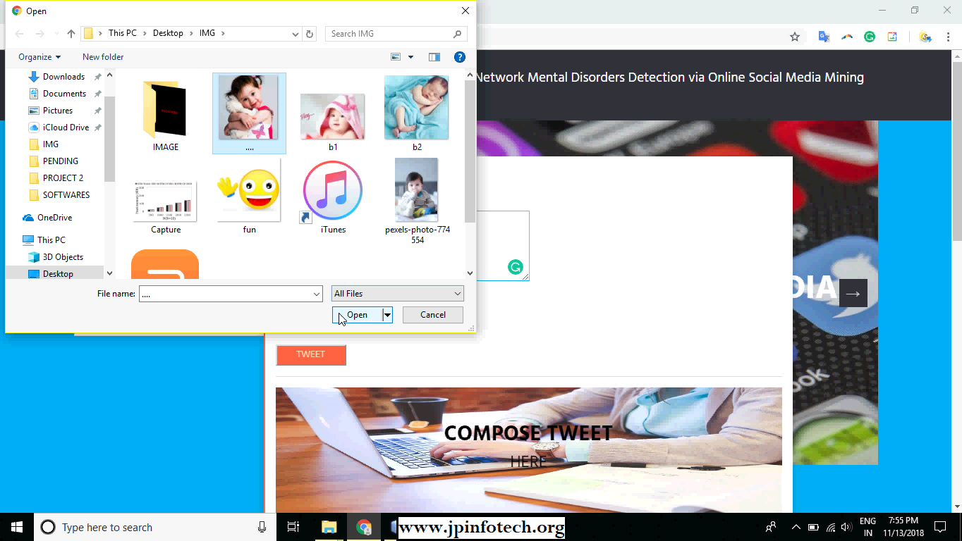



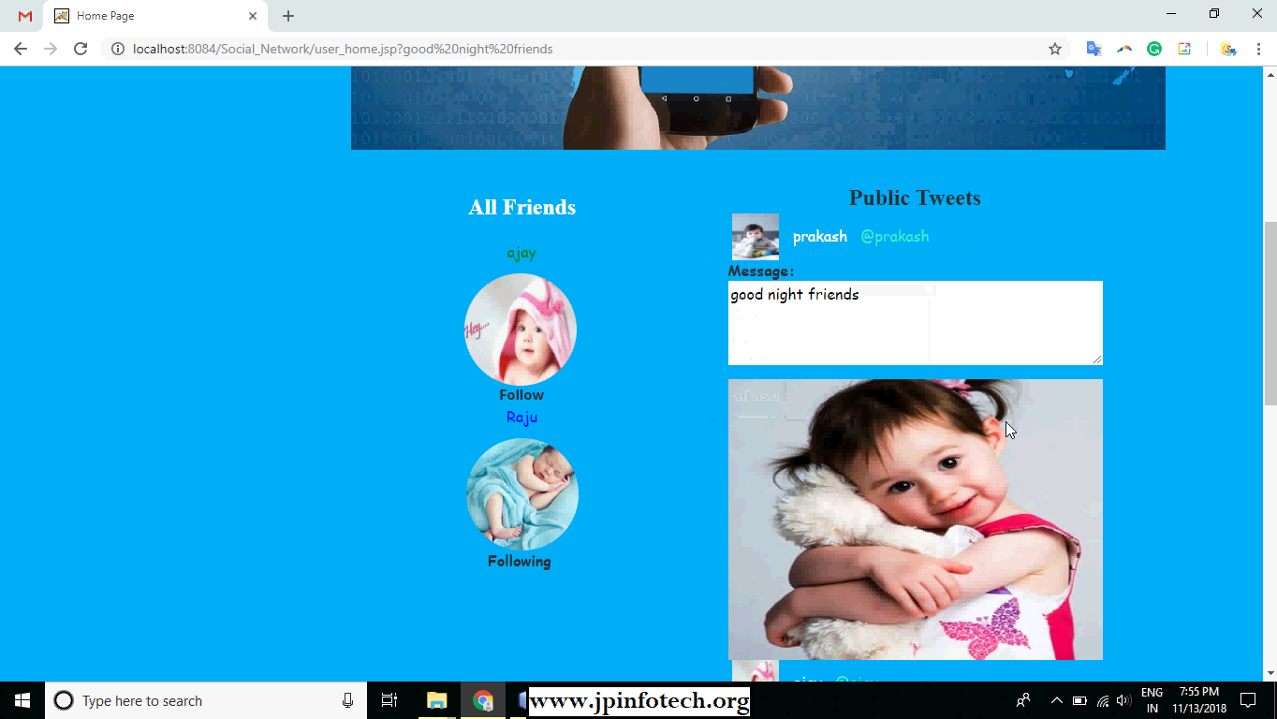









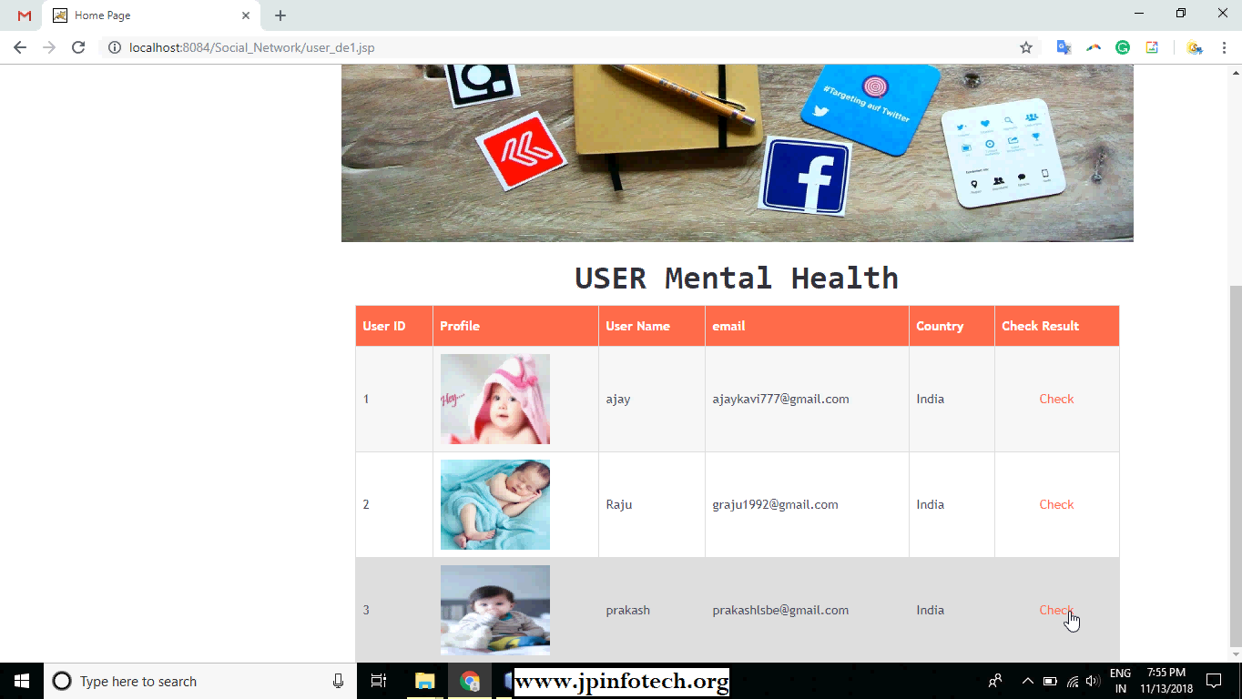

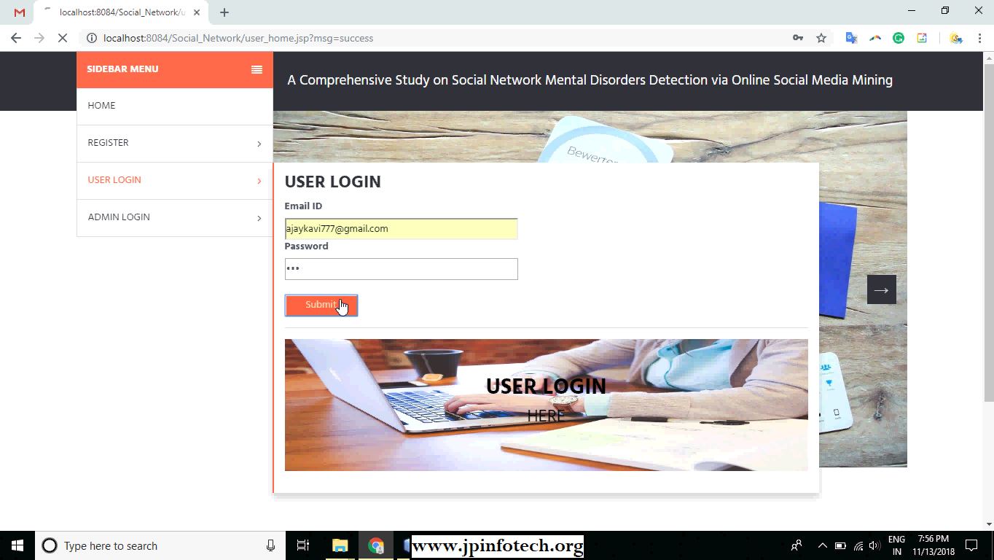

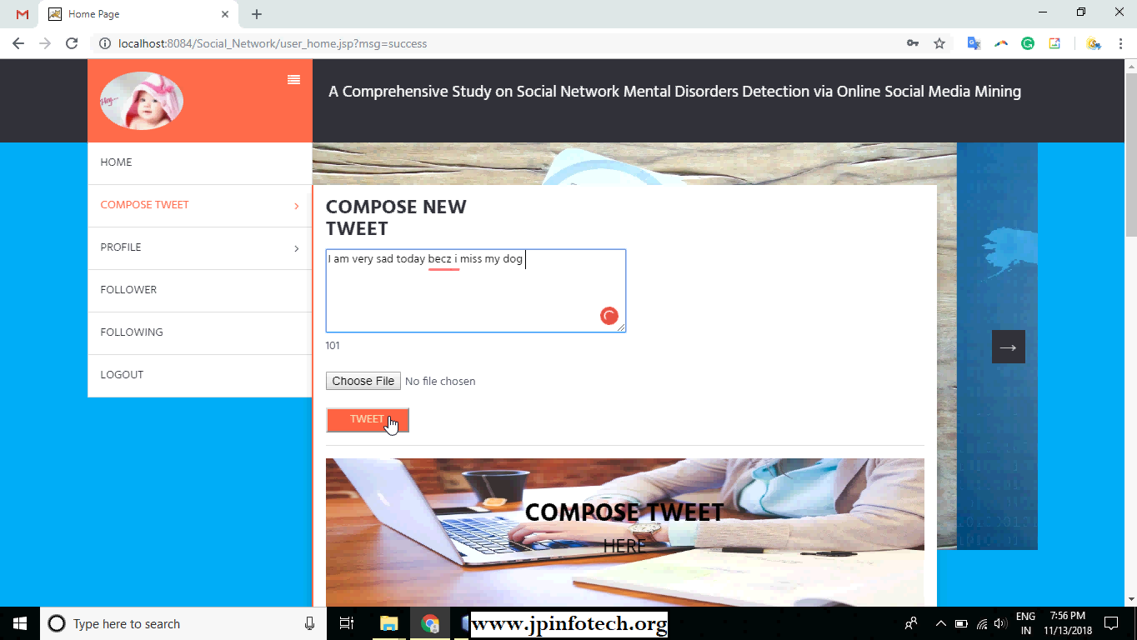



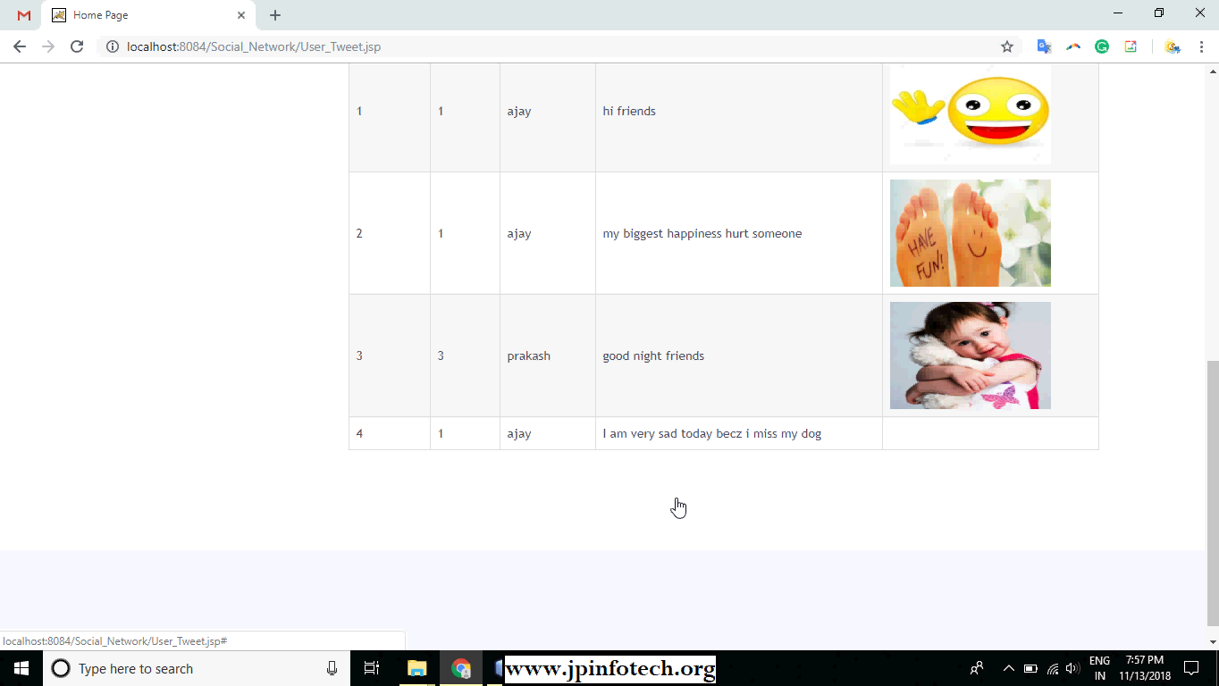

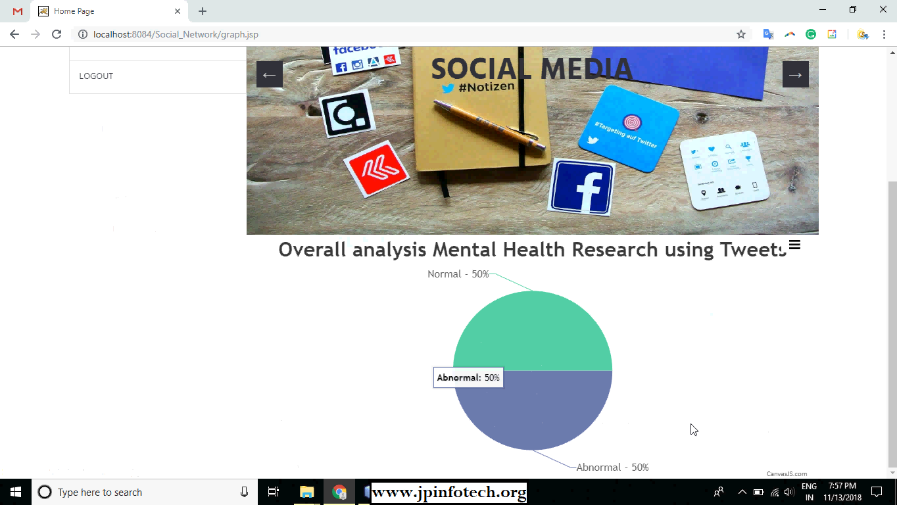



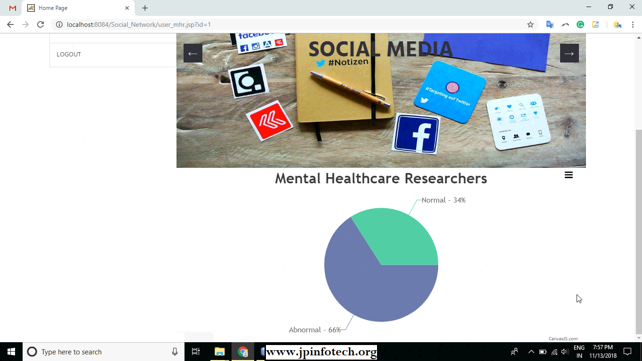

4.4 Quality Assurance

Certainly! Here are two points extracted from each section of the Quality Assurance Procedure for the Mental Health Evaluator Project:

1. **Requirement Validation:**

* Define and document detailed requirements for the Mental Health Evaluator project, including functionalities, user roles, and system behavior.
* Validate requirements with stakeholders, ensuring they accurately represent user needs and expectations.

1. **Testing and Verification:**

* Develop comprehensive test scenarios covering all aspects of the Mental Health Evaluator system, including user interface, functionality, performance, and security.
* Execute test cases rigorously to identify and address any issues or bugs in the system.

1. **Code Review and Compliance:**

* Conduct regular code reviews to ensure adherence to coding standards and best practices.
* Verify that the code is well-structured, readable, and maintainable.

1. **Documentation and Reporting:**

* Maintain up-to-date project documentation, including system architecture, design documents, and user manuals.
* Generate comprehensive reports summarizing testing activities, including test plans, test cases, test results, and defect logs.

1. **Continuous Improvement:**

* Solicit feedback from users and stakeholders to identify areas for improvement in the Mental Health Evaluator system.
* Continuously evaluate and enhance software quality through iterative development and testing cycles.

1. **Compliance with Standards and Best Practices:**

* Ensure compliance with industry standards and best practices for software development and quality assurance.
* Adhere to relevant regulations and guidelines governing mental health applications, such as GDPR and APA standards.

1. **Training and Skill Development:**

* Provide training and support to team members on quality assurance processes, tools, and techniques.
* Foster a culture of quality consciousness and accountability within the project team.

Chapter 5

Standards Adopted

* 1. Design Standards

**INPUT DESIGN**

The input design is the link between the information system and the user. It comprises the developing specification and procedures for data preparation and those steps are necessary to put transaction data in to a usable form for processing can be achieved by inspecting the computer to read data from a written or printed document or it can occur by having people keying the data directly into the system. The design of input focuses on controlling the amount of input required, controlling the errors, avoiding delay, avoiding extra steps and keeping the process simple. The input is designed in such a way so that it provides security and ease of use with retaining the privacy. Input Design considered the following things:

* What data should be given as input?
* How the data should be arranged or coded?
* The dialog to guide the operating personnel in providing input.
* Methods for preparing input validations and steps to follow when error occur.

**OBJECTIVES**

1. Input Design is the process of converting a user-oriented description of the input into a computer-based system. This design is important to avoid errors in the data input process and show the correct direction to the management for getting correct information from the computerized system.

2. It is achieved by creating user-friendly screens for the data entry to handle large volume of data. The goal of designing input is to make data entry easier and to be free from errors. The data entry screen is designed in such a way that all the data manipulates can be performed. It also provides record viewing facilities.

3. When the data is entered it will check for its validity. Data can be entered with the help of screens. Appropriate messages are provided as when needed so that the user will not be in maize of instant. Thus the objective of input design is to create an input layout that is easy to follow.

**OUTPUT DESIGN**

A quality output is one, which meets the requirements of the end user and presents the information clearly. In any system results of processing are communicated to the users and to other system through outputs. In output design it is determined how the information is to be displaced for immediate need and also the hard copy output. It is the most important and direct source information to the user. Efficient and intelligent output design improves the system’s relationship to help user decision-making.

1. Designing computer output should proceed in an organized, well thought out manner; the right output must be developed while ensuring that each output element is designed so that people will find the system can use easily and effectively. When analysis design computer output, they should Identify the specific output that is needed to meet the requirements.

2. Select methods for presenting information.

3. Create document, report, or other formats that contain information produced by the system.

The output form of an information system should accomplish one or more of the following objectives.

* Convey information about past activities, current status or projections of the
* Future.
* Signal important events, opportunities, problems, or warnings.
* Trigger an action.
* Confirm an action.

**5.2 Coding Standards**

Java technology encompasses both a programming language and a platform, offering various benefits such as simplicity, portability, and security. It supports the "write once, run anywhere" paradigm through Java byte codes interpreted by the Java Virtual Machine (JVM). The platform consists of the Java VM and the Java API, providing a wide range of functionalities, including networking, internationalization, security, and database connectivity.

JDBC (Java Database Connectivity) offers a standardized API for accessing databases, while JFree Chart enables the creation of professional-quality charts in Java applications. J2ME (Java 2 Micro Edition) extends Java's cross-platform capabilities to smaller devices like mobile phones and digital set-top boxes, with configurations like CLDC and profiles like MIDP catering to different device capabilities.

Considerations for developing applications on small devices include simplicity, minimizing memory usage, and optimizing performance. Various design strategies, configurations, and profiles are available to support the development of efficient and effective Java applications across different platforms and devices.

5.3 Testing Standards

System testing is conducted to ensure that the entire integrated software system meets requirements and functions as expected. It verifies the system's behavior and interactions, ensuring known and predictable results. Types of system tests include:

1. Integration Testing: Validates that integrated software components function as one program, focusing on the combination of components and exposing problems that arise from their integration.

2. Functional Testing: Demonstrates that functions are available as specified by business and technical requirements. It tests valid and invalid inputs, identified functions, outputs, and system/procedure interfaces.

3. Unit Testing: Tests individual software units to ensure internal program logic functions properly. It validates decision branches and internal code flow, ensuring each unique path of a business process performs accurately.

4. White Box Testing: Tests with knowledge of the inner workings, structure, or language of the software, focusing on areas unreachable from a black box level.

5. Black Box Testing: Tests the software without knowledge of its inner workings, focusing on inputs and outputs without considering how the software works internally.

System testing verifies the entire integrated software system, ensuring compliance with requirements and expected behavior, while unit testing focuses on individual units' functionality and internal logic.

*School of Computer Engineering, KIIT, BBSR* 18

Chapter 6

Conclusion and Future Scope

6.1 Conclusion

In this study, we aim to automatically detect potential online users with SNMDs by introducing an SNMDD framework. This framework utilizes various features extracted from data logs of online social networks (OSNs), along with a novel tensor technique for extracting latent features from multiple OSNs for SNMD detection. This collaborative effort between computer scientists and mental healthcare researchers addresses emerging issues in SNMDs. Our next step involves analyzing features extracted from multimedia content using techniques in natural language processing (NLP) and computer vision. Additionally, we plan to explore new issues from the perspective of social network service providers such as Facebook or Instagram, with the goal of enhancing the well-being of OSN users while maintaining user engagement.

6.2 Future Scope

The future scope of the mental disorder detection via social media mining project focuses on leveraging machine learning and Java web development to enhance personalized mental health assessments and support services. Key features include enhanced personalization through machine learning analysis of user data, real-time monitoring for timely intervention, multimodal assessment using various data sources, expanded support services, long-term progress tracking, accessibility and inclusivity measures, research collaborations for continuous improvement, data security and privacy measures, integration with healthcare systems, and user education and empowerment. By integrating these features, the project aims to revolutionize early detection and support for individuals at risk of mental disorders, ultimately leading to improved mental health outcomes and well-being in society.

**References**

[1] K. Young, M. Pistner, J. O’Mara, and J. Buchanan. Cyber-disorders: The mental health concern for the new millennium. *Cyberpsychol. Behav.*, 1999. (a) SNMD types of friends (FB L). (b) SNMD types of friends (IG L). (c) Ratios of SNMD users in communities (FB L). (d) Ratios of SNMD users in communities (IG L). (e) SNMD users. (f) Hop distance to same type SNMD users. Fig. 4. Comparisons of different datasets.

[2] J. Block. Issues of DSM-V: internet addiction. *American Journal of Psychiatry*, 2008.

[3] K. Young. Internet addiction: the emergence of a new clinical disorder, *Cyberpsychol. Behav.*, 1998.

[4] I.-H. Lin, C.-H. Ko, Y.-P. Chang, T.-L. Liu, P.-W. Wang, H.-C. Lin, M.-F. Huang, Y.-C. Yeh, W.-J. Chou, and C.-F. Yen. The association between suicidality and Internet addiction and activities in Taiwanese adolescents. *Compr. Psychiat.*, 2014.

[5] Y. Baek, Y. Bae, and H. Jang. Social and parasocial relationships on social network sites and their differential relationships with users’ psychological well-being. *Cyberpsychol. Behav. Soc. Netw.*, 2013.

[6] D. La Barbera, F. La Paglia, and R. Valsavoia. Social network and addiction. *Cyberpsychol. Behav.*, 2009.

[7] K. Chak and L. Leung. Shyness and locus of control as predictors of internet addiction and internet use. *Cyberpsychol. Behav.*, 2004.

[8] K. Caballero and R. Akella. Dynamically modeling patients health state from electronic medical records: a time series approach. *KDD*, 2016.

[9] L. Zhao and J. Ye and F. Chen and C.-T. Lu and N. Ramakrishnan. Hierarchical Incomplete multi-source feature learning for Spatiotemporal Event Forecasting. *KDD*, 2016.

[10] E. Baumer, P. Adams, V. Khovanskaya, T. Liao, M. Smith, V. Sosik, and K. Williams. Limiting, leaving, and (re)lapsing: an exploration of Facebook non-use practices and experiences. *CHI*, 2013.

[11] R. Jain and N. Abouzakhar. A comparative study of hidden markov model and support vector machine in anomaly intrusion detection. *JITST*, 2013.

[12] C. Tan, L. Lee, J. Tang, L. Jiang, M. Zhou, and P. Li. User-level sentiment analysis incorporating social networks. *KDD*, 2011.

[13] R. Collobert, F. Sinz, J. Weston, and L. Bottou. Large scale transductive svms. *JMLR*, 2006.

[14] L. Leung. Net-generation attributes and seductive properties of the internet as predictors of online activities and internet addiction. *Cyberpsychol. Behav. Soc. Netw.*, 2004.

[15] J. Cacioppo, J. Fowler, and N. Christakis. Alone in the crowd: the structure and spread of loneliness in a large social network. *J. Pers. Soc. Psychol.*, 2009.

[16] J. Kleinberg. Bursty and hierarchical structure in streams. *KDD*, 2002.

[17] K.-L. Liu, W.-J. Li, and M. Guo. Emoticon smoothed language models for twitter sentiment analysis. *AAAI*, 2012.

[18] C. Andreassen, T. Torsheim, G. Brunborg, and S. Pallesen. Development of a Facebook addiction scale. *Psychol. Rep.*, 2012.

[19] B. Viswanath, A. Mislove, M. Cha, and K. P. Gummadi. On the evolution of user interaction in Facebook. *WOSN*, 2009.

[20] E. Ferrara, R. Interdonato, and A. Tagarelli. Online popularity and topical interests through the lens of Instagram. *HT*, 2014.

[21] M. Saar-Tsechansky and F. Provost. Handling missing values when applying classification models. *JMLR*, 2007.

[22] I. Witten and E. Frank. Data mining: practical machine learning tools and techniques with Java implementations. Morgan- Kaufmann, San Francisco, 2000.

[23] C.-C. Chang and C.-J. Lin. LIBSVM: a library for support vector machines, 2001.

[24] F. Chang, C.-Y. Guo, X.-R. Lin, and C.-J. Lu. Tree decomposition for large-scale SVM problems. *JLMR*, 2010.

[25] P. Comon, X. Luciani, and A. L. D. Almeida. Tensor decompositions, alternating least squares and other tales. *Journal of Chemometrics*, 2009.

[26] E. Acar, D. M. Dunlavy, and T. G. Kolda. A scalable optimization approach for fitting canonical tensor decompositions. *Journal of Chemometrics*, 2011.

[27] L. He, C.-T. Lu, J.Ma, J. Cao, L. Shen, and P. S. Yu. Joint community and structural hole spanner detection via harmonic modularity. *KDD*, 2016.

[28] M. Cha, H. Haddadi, F. Benevenuto, and K. P. Gummad. Measuring user influence on twitter: The million follower fallacy. *ICWSM*, 2010.

[29] K. Hayashi, T. Maehara, M. Toyoda, and K. Kawarabayashi. Realtime top-r topic detection on twitter with topic hijack filtering. *KDD*, 2015.

[30] J. Gill and G. King. What to do when your Hessian is not invertible: Alternatives to model respecification in nonlinear estimation. *Sociological Methods and Research*, 2004.

[31] B. K˚agstr¨om and P. Poromaa. Distributed and shared memory block algorithms for the triangular Sylvester equation with sep−1 estimators. *SIAM Journal on Matrix Analysis and Applications*, 1992.

[32] L. R. Tucker. Some mathematical notes on three-mode factor analysis. *Psychometrika*, 1966.

[33] R.A. Harshman. Foundations of the PARAFAC procedure: Models and conditions for an explanatory multimodal factor analysis. *UCLA Working Papers in Phonetics*, 1970.

[34] S. Graham, A. Munniksma, J. Juvonen. Psychosocial benefits of cross-ethnic friendships in urban middle schools. *Child Development*, 2013.

[35] S. S. Levine, E. P. Apfelbaum, M. Bernard, V. L. Bartelt, E. J. Zajac, and D. Stark. Ethnic diversity deflates price bubbles. *National Academy of Sciences*, 2014.

[36] H. Appel, J. Crusius, and Alexander L. Gerla. Social comparison, envy, and depression on facebook: a study looking at the effects of high comparison standards on depressed individuals. *Journal of Social and Clinical Psychology*, 2015.

[37] A. Bordes, L. Bottou, and P. Gallinari. SGD-QN: careful quasinewton stochastic gradient descent. *Journal of Machine Learning Research*, 2009.

[38] J. B. White, E. J. Langer, L. Yariv, and J. C. Welch IV. Frequent social comparisons and destructive emotions and behaviors: the dark side of social comparisons. *Journal of Adult Development*, 2006.

[39] M. Rosvall and C. Bergstrom. Maps of random walks on complex networks reveal community structure. *Natl. Acad. Sci.*, 2008.

[40] D. L. King, P. H. Delfabbro, D. Kaptsis, and T. Zwaans. Adolescent simulated gambling via digital and social media: an emerging problem. *Computers in Human Behavior*, 2014.

[41] D. Li, X. Li, L. Zhao, Y. Zhou, W. Sun, and Y. Wang. Linking multiple risk exposure profiles with adolescent Internet addiction: insights from the person-centered approach. *Computers in Human Behavior*, 2017.

[42] K. Kim, H. Lee, J. P. Hong,M. J. Cho, M. Fava,D. Mischoulon, D. J. Kim, and H. J. Jeon. Poor sleep quality and suicide attempt among adults with internet addiction: a nationwide community sample of Korea. *PLOS ONE*, 2017.

[43] C.-H Chang, E. Saravia, and Y.-S. Chen. Subsonscious crowdsourcing: a feasible data collection mechanism for mental disorder detection on social media, *ASONAM*, 2016.

[44] B. Saha, T. Nguyen, D. Phung, and S. Venkatesh. A framework for classifying online mental health-related communities with an interest in depression. *IEEE Journal of Biomedical and Health Informatics*, 2016.

[45] M. Choudhury, M. Gamon, S. Counts, and E. Horvitz. Predicting depression via social media. *ICWSM*, 2013.

[46] T. Kolda and B. Bader. Tensor decompositions and applications. *SIAM review*, 2009.

[47] H.-H. Shuai, C.-Y. Shen, D.-N. Yang, Y.-F. Lan, W.-C. Lee, P. S. Yu, and M.-S. Chen. Mining online social data for detecting social network mental disorders. *WWW*, 2016.

[48] A. Anandkumar, D. Hsu, M. Janzamin, and S. Kakade. When are overcomplete topic models identifiable? uniqueness of tensor tucker decompositions with structured sparsity. *JLMR*, 2015.

[49] L. Bottou. Stochastic gradient descent tricks. *Neural Networks: Tricks of the Trade*, 2012.

[50] J. M. Ortega and W. C. Rheinboldt. Iterative Solution of Nonlinear Equations in Several Variables. Academic Press, NY, 1970.

[51] Y. Nesterov and B. T. Polyak. Cubic regularization of Newton method and its global performance. *Mathematical Programming*, 2006.

[52] R. Ge, F. Huang, C. Jin, and Y. Yuan. Escaping from saddle pointsonline stochastic gradient for tensor decomposition. *Conference of Learning Theory (COLT)*, 2015.

[53] T. Maehara, K. Hayashi, and K. Kawarabayashi. Expected tensor decomposition with stochastic gradient descent. *AAAI*, 2016.

[54] V. Silva and L.-H. Lim. Tensor rank and the ill-posedness of the best low-rank approximation problem. *SIAM Journal on Matrix Analysis and Applications*, 2006.

*School of Computer Engineering, KIIT, BBSR* 20

Aniket Kumar Mishra

2029187

* **Individual contribution and findings:** In our project my role was to develop a Full-Stack Mental Health Evaluator using Java and machine learning integration, my role was focused on frontend development and user interface (UI)/user experience (UX) design. This report provides a detailed overview of my contributions, highlighting my expertise in crafting intuitive interfaces and optimizing user engagement.

UI/UX Design: My primary responsibility was to conceptualize and design the user interface for our Mental Health Evaluator application. I meticulously crafted UI components, considering user preferences, accessibility requirements, and design principles to ensure an optimal user experience. My designs aimed to create a visually appealing and intuitive interface that would resonate with our target audience.

* **Individual contribution to project report preparation:** As a team member of the Full-Stack Mental Health Evaluator project, my role in preparing the project report encompassed several key responsibilities. My contributions were centered around organizing, formatting, and presenting the project's details and outcomes in a clear and compelling manner.

My first task involved compiling all relevant information related to the project, including technical specifications, design considerations, implementation strategies, and evaluation results. I meticulously gathered data from various sources, ensuring that every aspect of the project was thoroughly documented and accounted for in the report.



Full Signature of Supervisor: Full signature of the student:

……………………………. ……………………………..

Ujjwal Singh

2029193

* **Individual contribution and findings:** I actively participated in gathering requirements, which included learning about the objectives of the project and getting feedback from stakeholders. Additionally, I worked on the system's back-end development using the Java programming language, which led to the creation of a reliable and effective server-side logic . My contributions included designing and implementing REST ful APIs for data retrieval and processing. I integrated data scraping modules to collect social media data and pre process it for analysis. Additionally, I developed database schemas and implemented data persistence mechanisms to store and manage user data securely.
* **Individual contribution to project report preparation:** My involvement in the study included helping to develop the software requirements specification (SRS) and resolving the report's issue statement. Through the articulation of the existing challenges and their identification, the project scope was clearly understood. The SRS document provided the development team with a well-organized and documented project by outlining features like tracking comments, tracking social media accounts for the website. In order to gain a solid knowledge of the project's core concepts, relevant research materials were also carefully evaluated to discover approaches and instruments utilized in similar studies. These contributions were extremely important in determining the project's strategy and results.



Full Signature of Supervisor: Full signature of the student:

……………………………. ……………………………..

Abdul Wahid Aadil

2029194

* **Individual contribution and findings:**I took on the database implementation, which included setting up the MySQL database, creating tables, and creating associations. In order to guarantee data integrity and maximize storage, I also applied normalization techniques to the database architecture. These efforts made sure that the database structure for the mental health evaluator system was efficient and effective. My responsibilities included conceptualizing the project idea, outlining the project objectives, and delegating tasks to team members. I was instrumental in defining the scope of the project and ensuring its alignment with our skills and resources. I also collaborated closely with Siddharth and Ankit to integrate the machine learning models seamlessly into the backend infrastructure along with my datasets.
* **Individual contribution to project report preparation:** My contributions to the report included ensuring that the standards section adhered to industry best practices. This included creating coding and design guidelines that encourage the best possible code organization, naming patterns, commenting, and documentation. Optimizing code performance and maintainability was prioritized. In the system design and architecture section, I also made a contribution that described the general organization of the system, including component identification, interaction, and data flow.



Full Signature of Supervisor: Full signature of the student:

……………………………. ……………………………..

Ankit Dev

2029195

**Individual contribution and findings:** In our project, I took on a significant role in Java back-end development, leveraging my expertise in Java programming and back-end technologies. My primary focus was on designing and implementing the back-end infrastructure that facilitated data retrieval, processing, and storage.

To start, I worked closely with Abdul to define the project requirements and outline the back-end architecture. We decided to implement a REST full API architecture to facilitate communication between the front end and back-end components. I then proceeded to design the API endpoints and data models necessary for our application.

Using Java frameworks such as Spring Boot or Jakarta EE, I implemented the back-end logic responsible for handling HTTP requests and responses. This involved writing controllers, services, and repositories to handle various CRUD (Create, Read, Update, Delete) operations on our data.

One of the critical functionalities I implemented was data scraping modules to collect social media data. I utilized Java libraries like J soup for web scraping, allowing us to extract relevant information from social media platforms while adhering to ethical guidelines and data privacy regulations.

Additionally, I focused on data pre processing tasks within the back-end. I developed algorithms to clean and transform the collected data into a format suitable for analysis by our machine learning models. This involved tasks such as text normalization, feature extraction, and data validation.

* **Individual contribution to project report preparation:** I provided a lot of contributions to the report's introduction and fundamental concepts parts. The importance of the initiative was emphasized, and the opening provided a summary of the report. The methodologies and tools employed in related studies were identified for the section on fundamental ideas after a thorough examination of pertinent research materials. My contributions helped the project's approach and results, laying a solid groundwork



Full Signature of Supervisor: Full signature of the student:

……………………………. …………………………….

Siddarth

2029214

* **Individual contribution and findings:** My expertise in machine learning played a pivotal role in this project. I focused on developing predictive models for mental health evaluation using Java-based libraries like Weka or Deeplearning4j. I experimented with various algorithms, such as decision trees, neural networks, and support vector machines, to identify the most effective approach. I collaborated closely with Abdul and Ankit to integrate the machine learning models seamlessly into the backend infrastructure.

In our project to develop a Full-Stack Mental Health Evaluator using Java and machine learning integration, my focus was on natural language processing (NLP) techniques. This report provides a detailed overview of my contributions to the project, specifically in the realm of NLP.

Understanding Mental Health Discussions: One of the primary challenges we faced was extracting meaningful insights from social media data related to mental health. My role involved designing and implementing NLP algorithms to analyze user-generated content and identify relevant discussions about mental health.

* **Individual contribution to project report preparation:** I gave input to the report's methodology/proposal, outcome analysis, and quality parts. The methodology/proposal part provided a clear idea of the project's completion by outlining the steps and procedures required to develop various website components. The aspect of quality assurance was also covered, making sure that procedures were followed during the planning and execution of the project. A visual picture was given by including screenshots of several website section



Full Signature of Supervisor: Full signature of the student:

……………………………. ……………………………..

*School of Computer Engineering, KIIT, BBSR*